1. create two files - student.txt and employee.txt and add them to staging area

1. add one more file - dept.txt into staging area but at same time restore the employee.txt and modify some changes inside the student.txt

Before After

1. push dept.txt and employee.txt to the remote repos

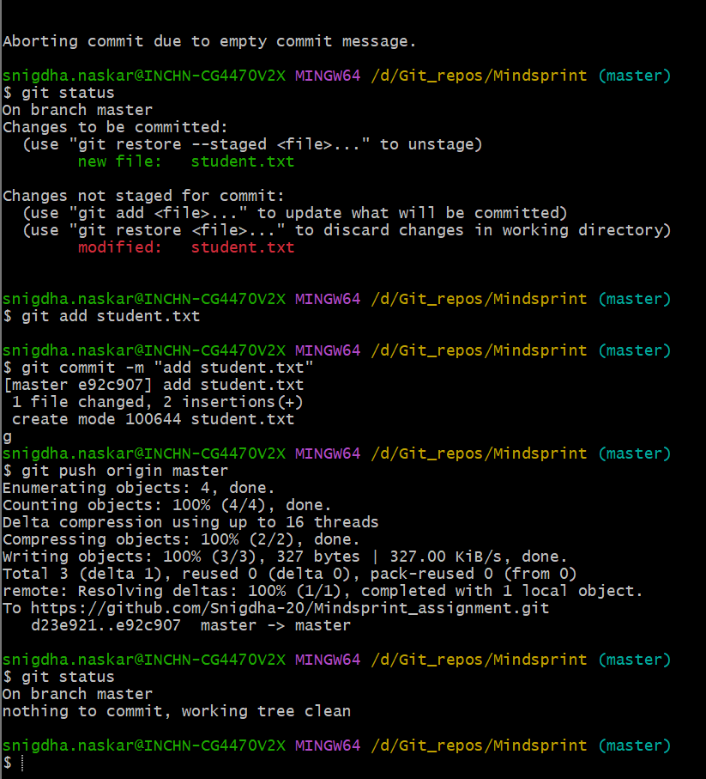

1. create a new file - hello.txt in remote repos directly and bring to the working directory

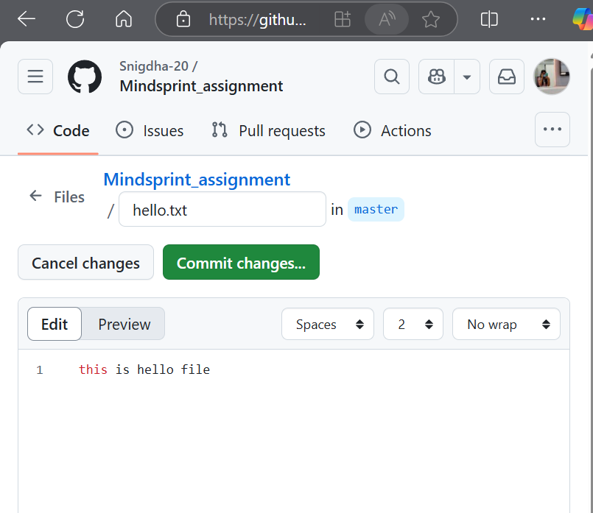

1. remove a file from the remote repos and sync the changes into your working directory



